Identify your chosen story: _____________________________________________

Which elements (and sub-elements) are most visible?

Which are missing or only implied?

Do any modules feel stalled or de-activated?

What else strikes you as interesting?

Map the Narrative to KARDS: Mark the chart provided to show where you see modules being activated in the story.

Jot down a few words to justify your choices around he A4 version of the chart.

Debrief with your group: What insight or point of disagreement did your group identify?

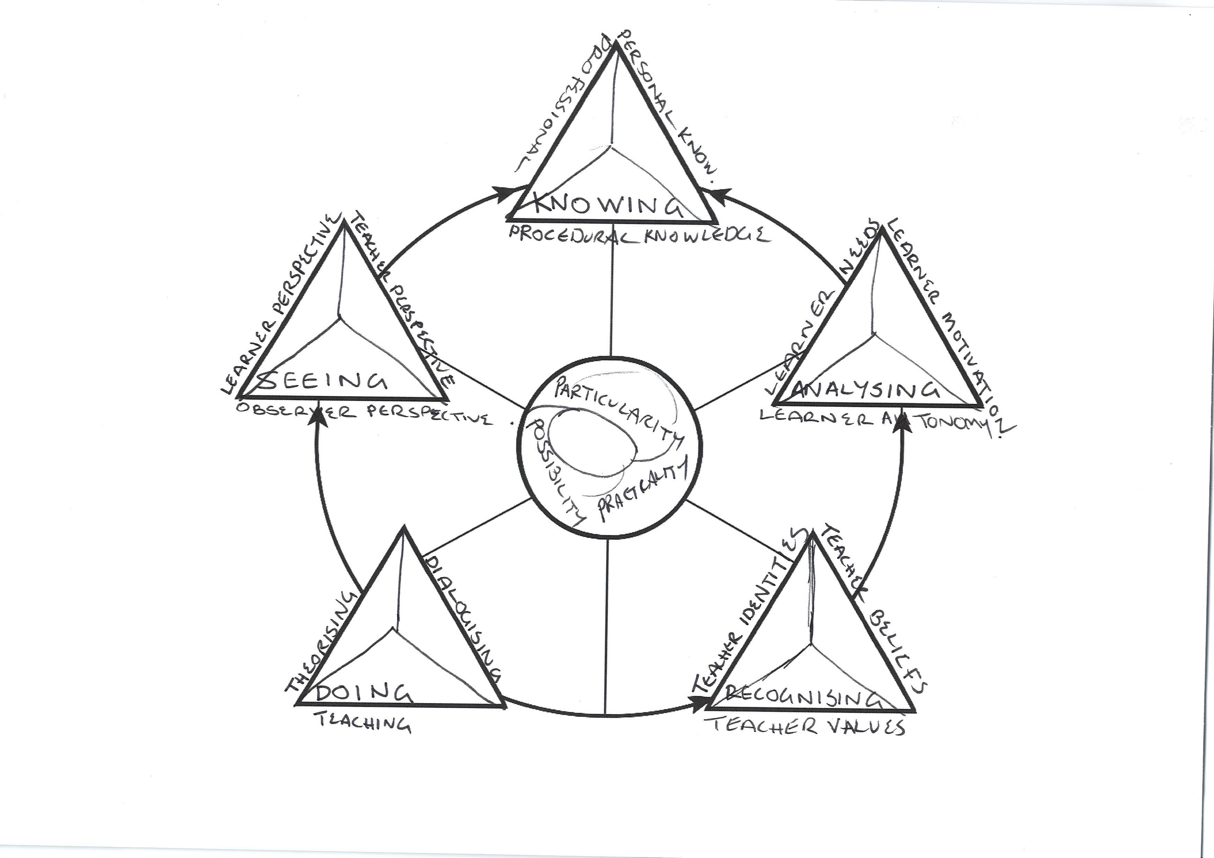

Kumaravadivelu, B. (2012). Language teacher education for a global society: A modular model for knowing, analyzing, recognizing, doing, and seeing (1st ed). Routledge/Taylor and Francis.

